





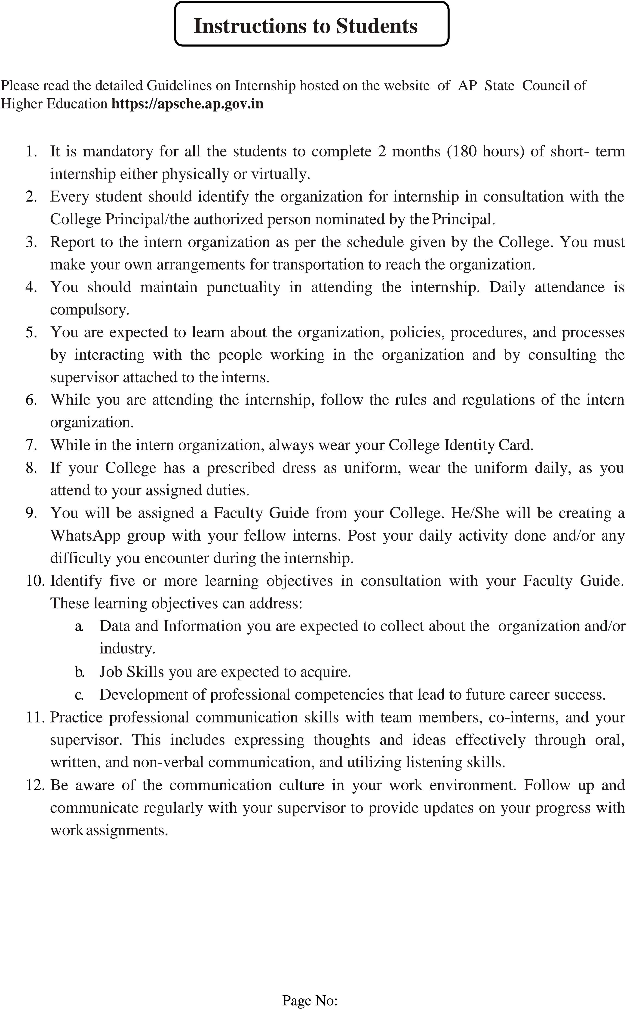

























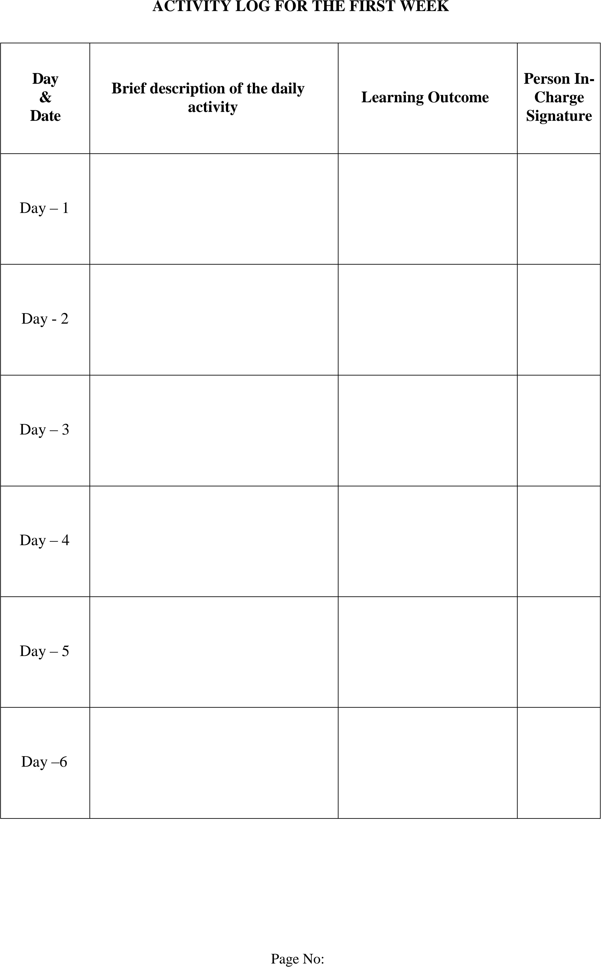



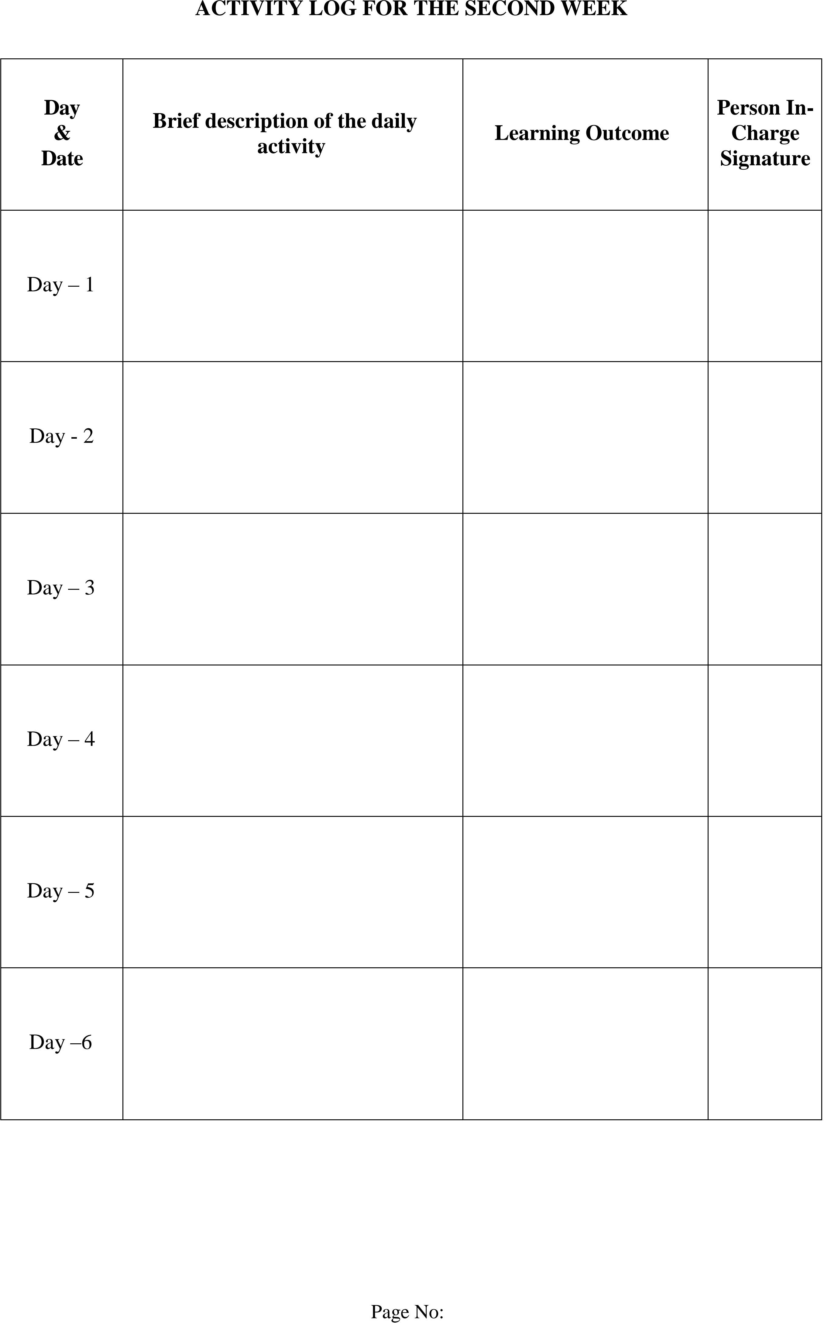



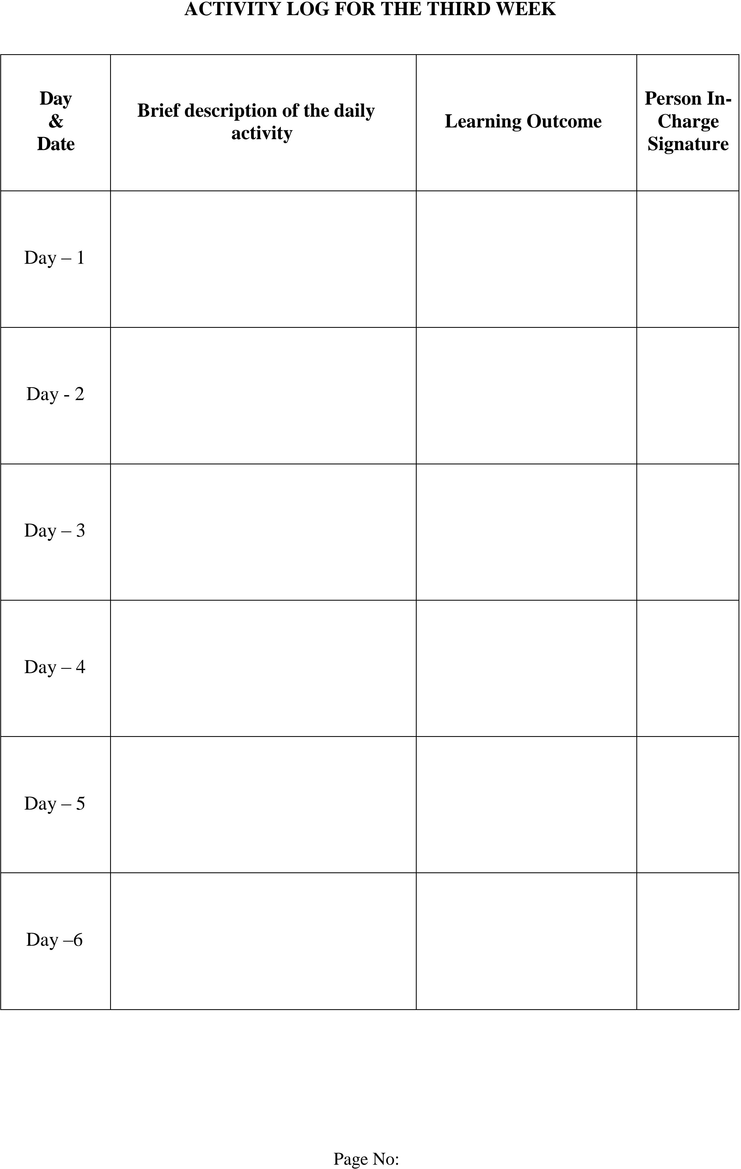



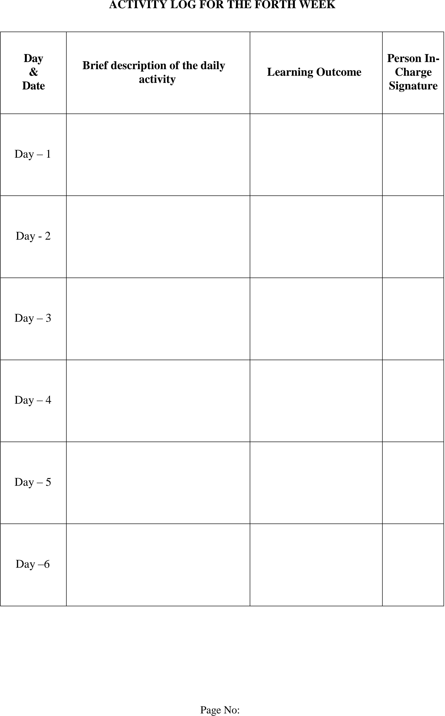



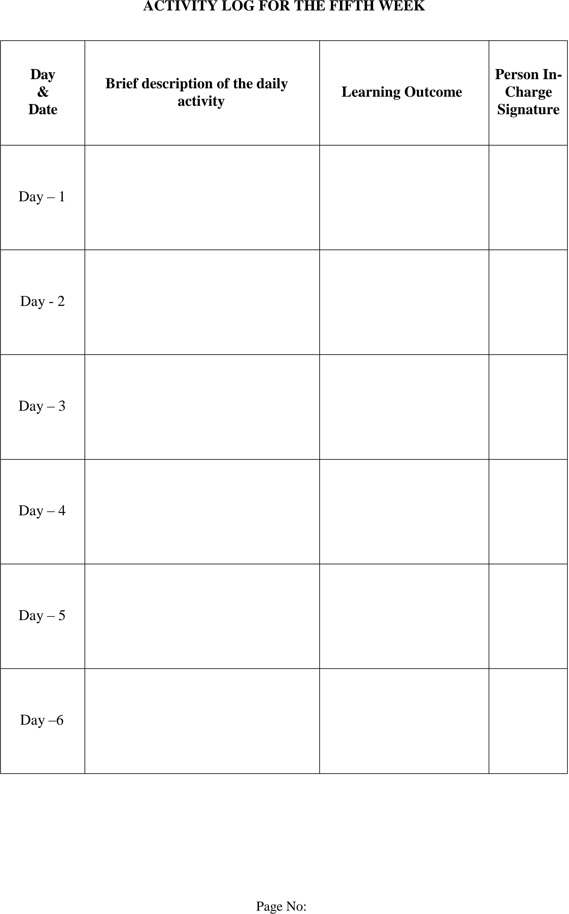



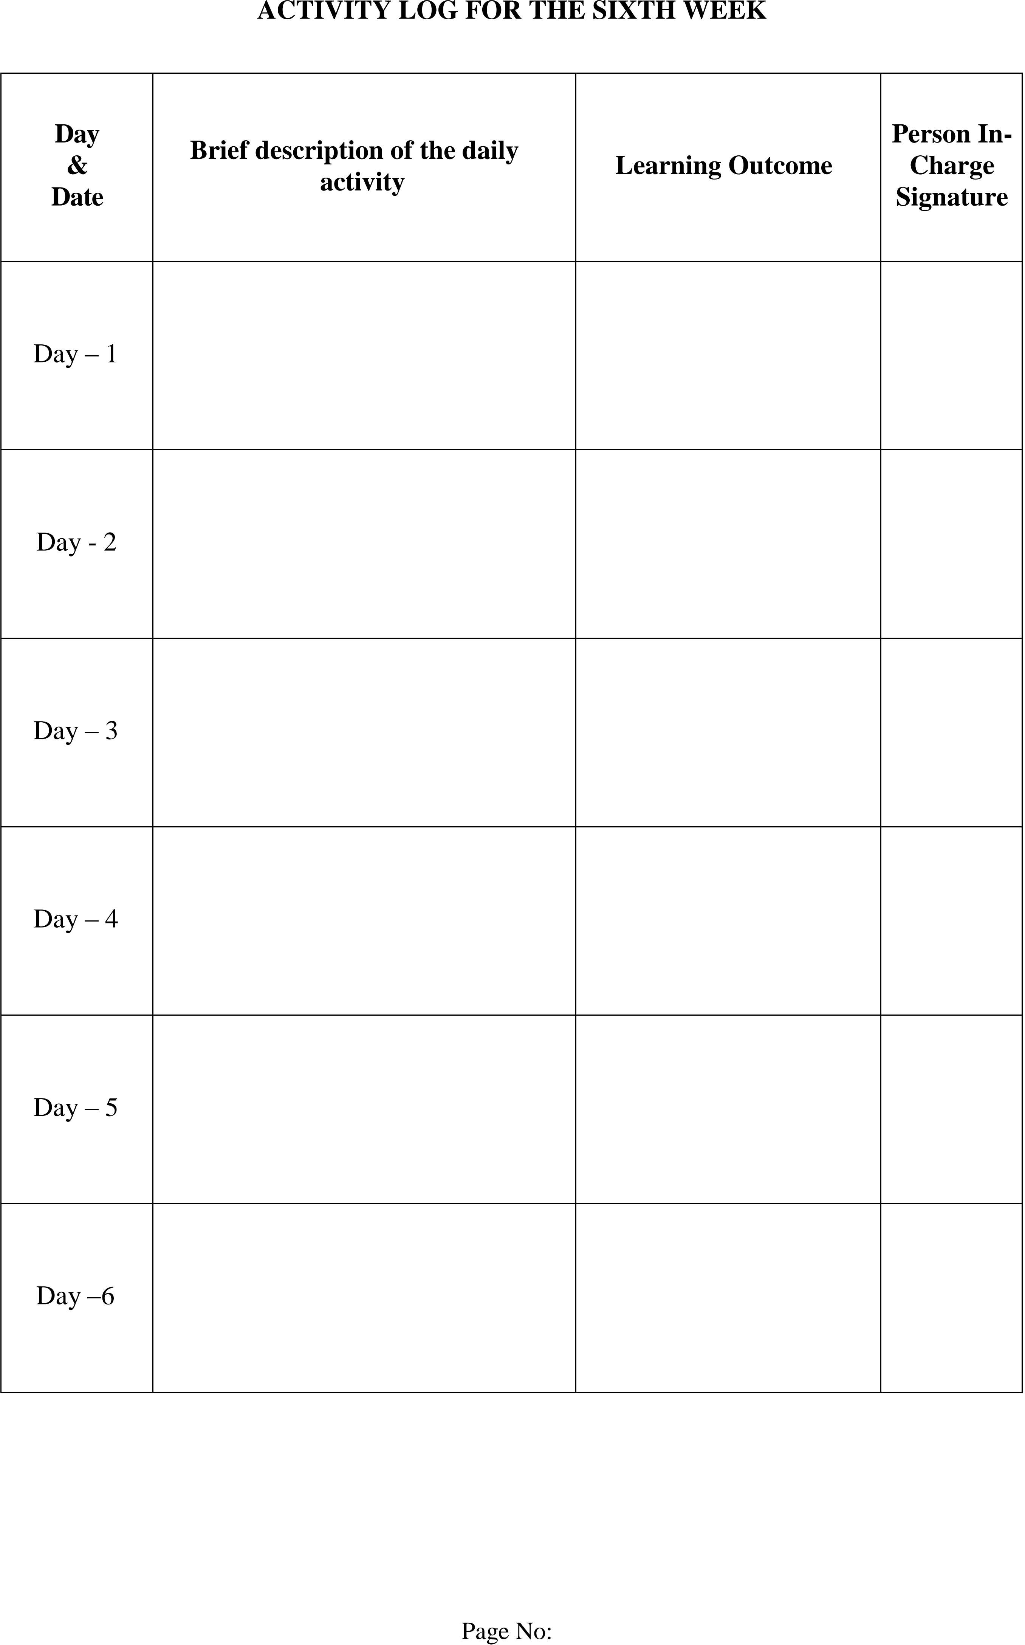



























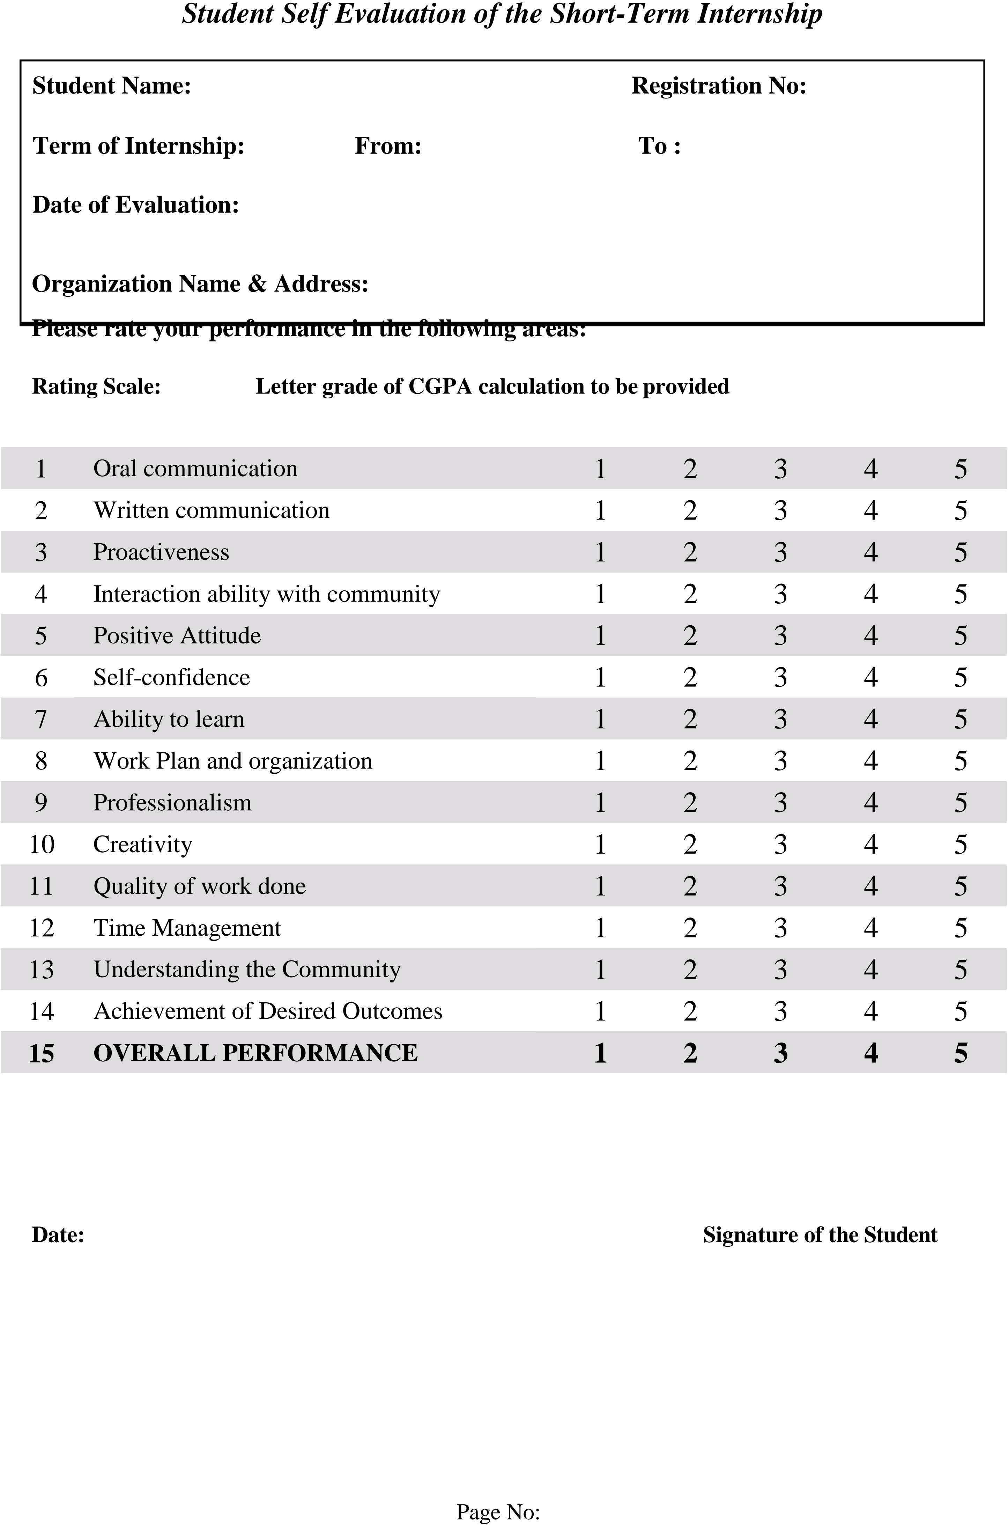

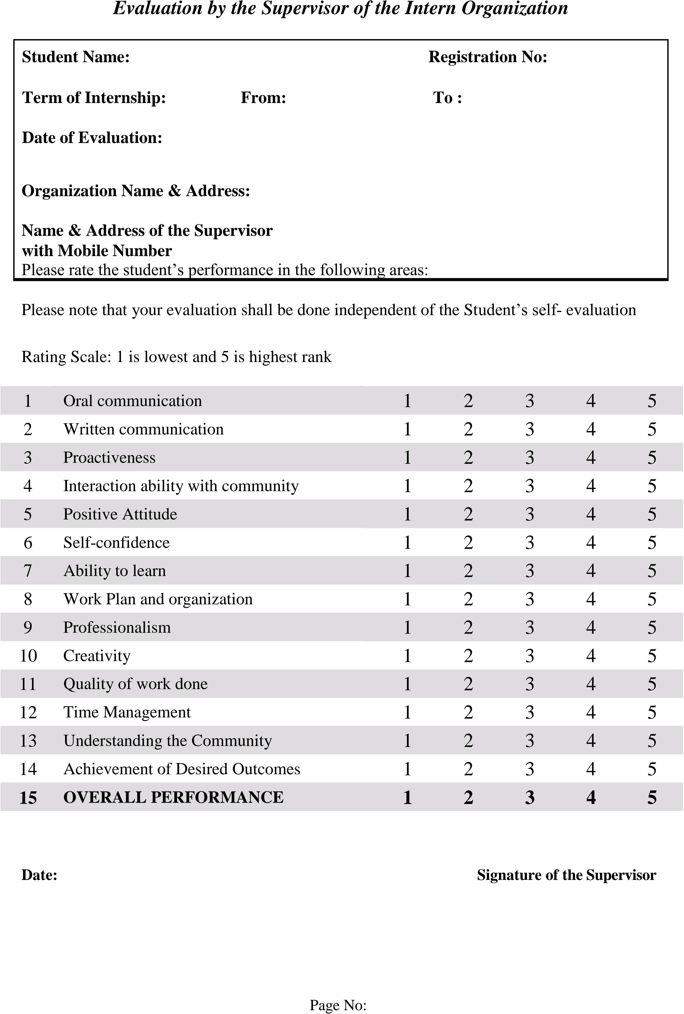

**PHOTOS AND VIDEO LINKS**

**Responsiveness And Design Of A Dashboard:**

The responsiveness and design of a dashboard for analysing the factors important for analysis of travel aggregators is crucial to ensure that the information is easily understandable and actionable. Key considerations for designing a responsive and effective dashboard include user-centred design, clear and concise information,etc. The goal is to create a dashboard that is user-friendly, interactive, and data-driven, providing actionable insights.

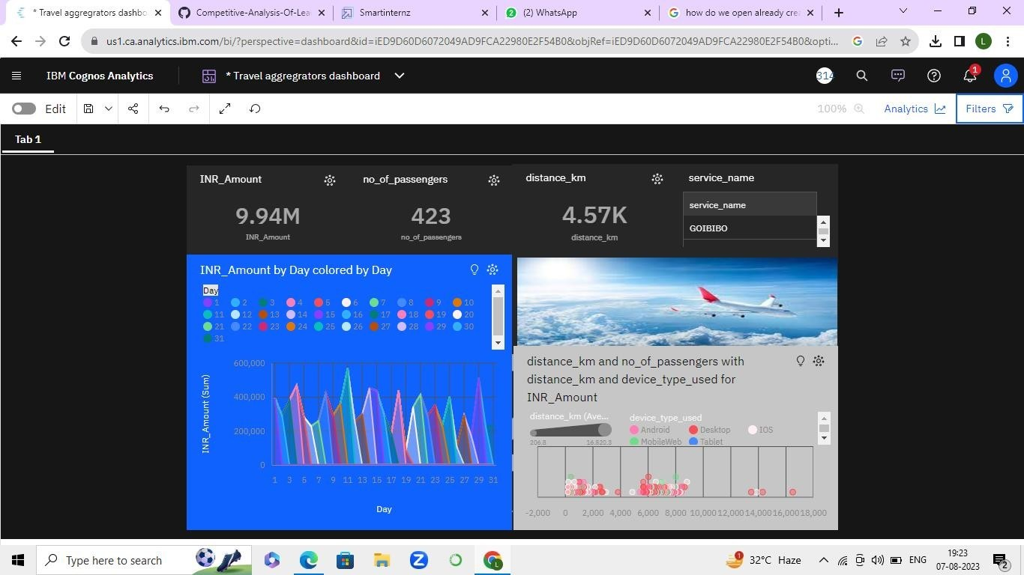

**TRAVEL AGGREGATOR REPORT:**

A report is a document that presents information in a specific format and layout, usually based on data from a database or other data source. A report in IBM Cognos can contain various elements, such as tables, charts, graphs, and images, as well as text and data elements, and it is designed to be used by business users to help them better understand their data and make informed decisions.

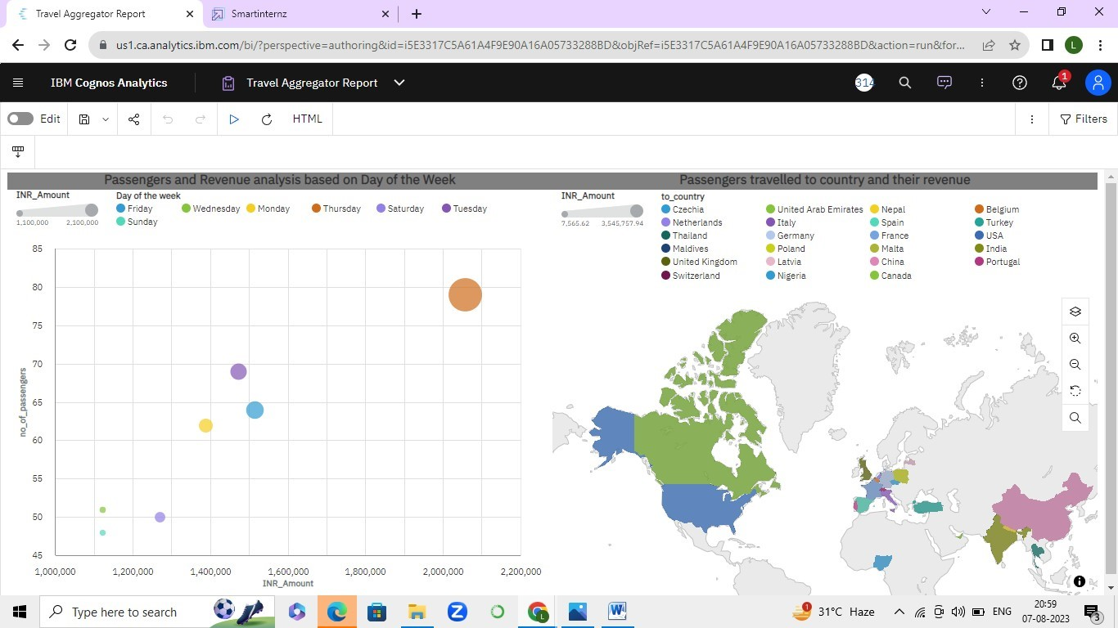



### Story:

### A data story is a way of presenting data and analysis in a narrative format, with the goal of making the information more engaging and easier to understand. A data story typically includes a clear introduction that sets the stage and explains the context for the data, a body that presents the data and analysis in a logical and systematic way, and a conclusion that summarizes the key findings and highlights their implications.



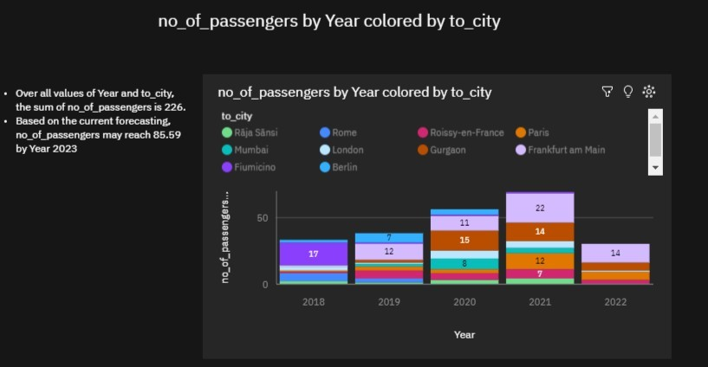



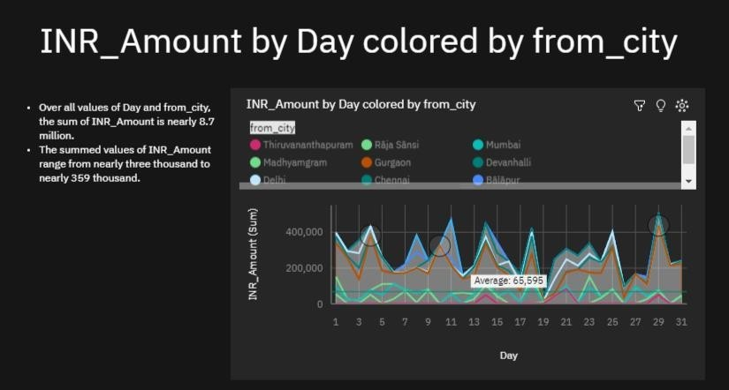

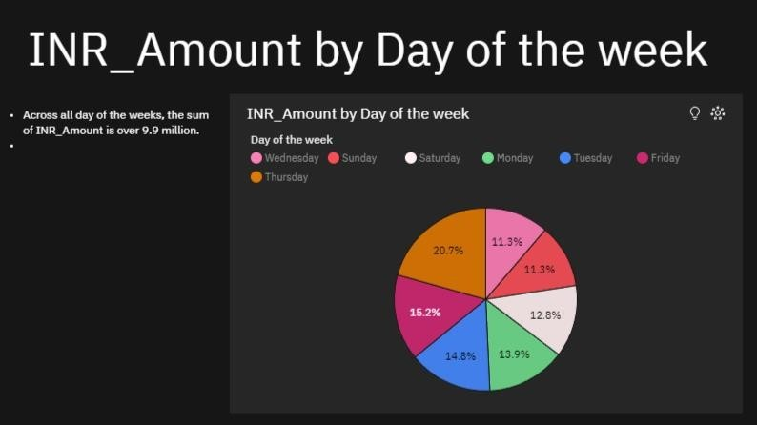



### Web Integration

Publishing helps us to track and monitor key performance metrics, to communicate results and progress. help a publisher stay informed, make better decisions, and communicate their performance to others.

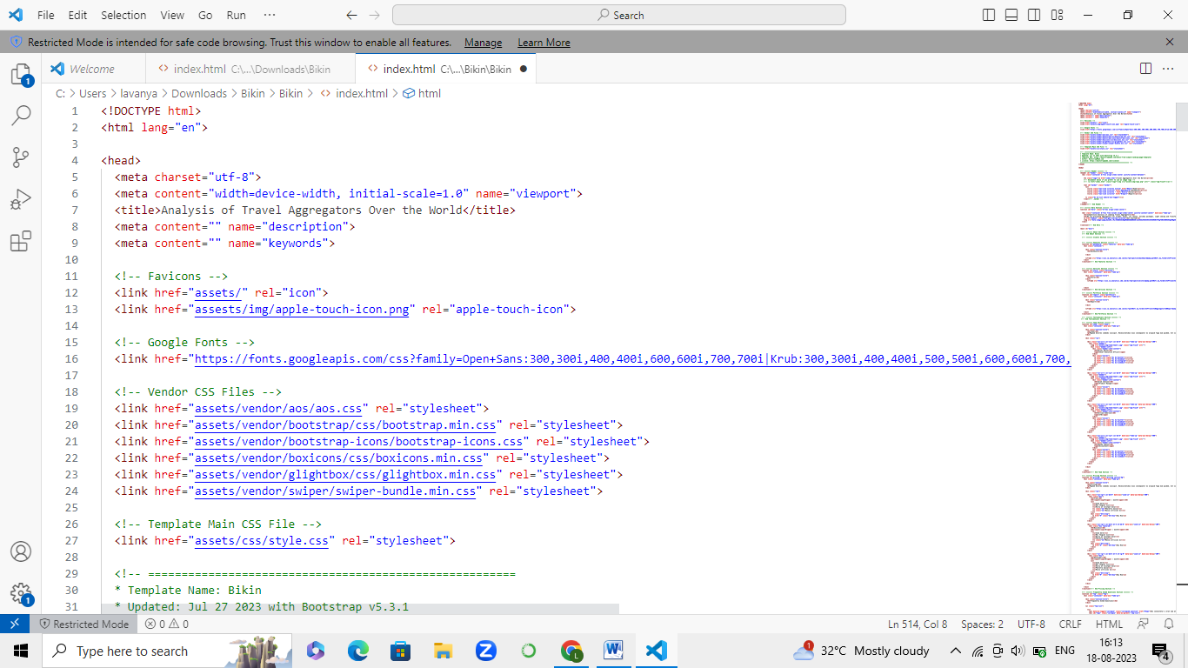

The above code represents the main header files required to execute the code. It is written in Python language and by using standard libraries we started writing the code.

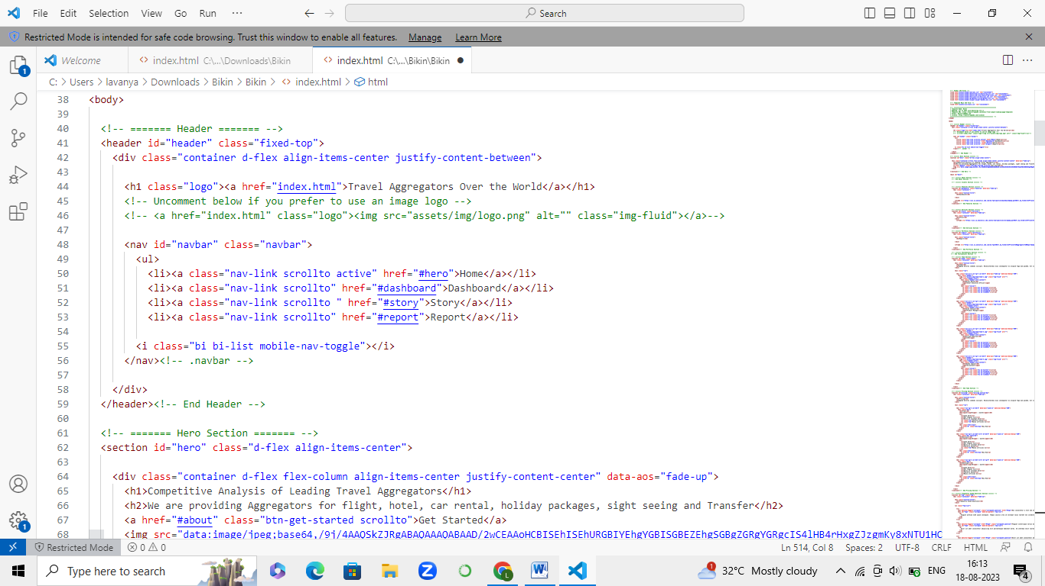

This code gives the output of the main headings i.e., Dashboard, Report and Story are being present at the right corner of the web page.



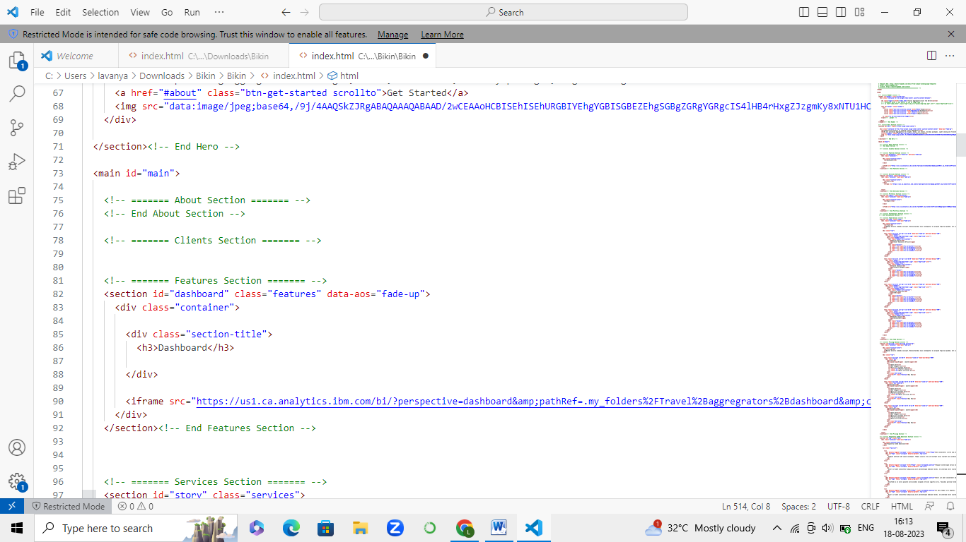

The above code gives the Dashboard of Travel analysis which is being done on IBM Cognus and using the code present in the IBM, we used the dimensions and width to display the image.

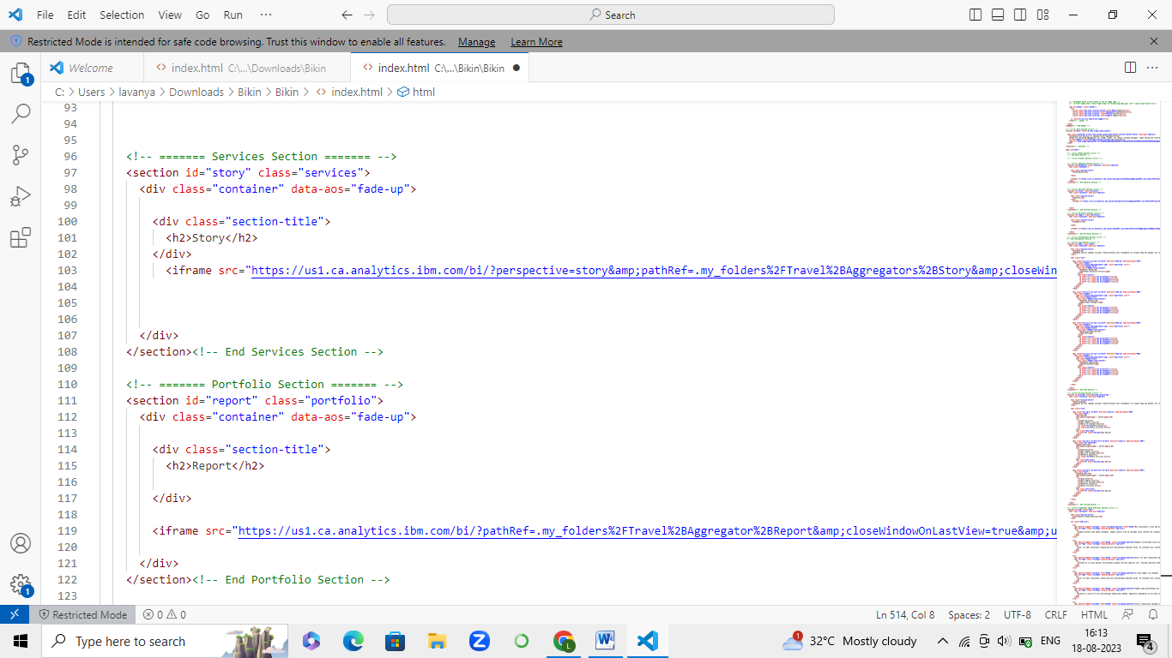

The above code gives the Story of Travel analysis which is being done on IBM Cognus and using the code present in the IBM, we used the dimensions and width to display the image.



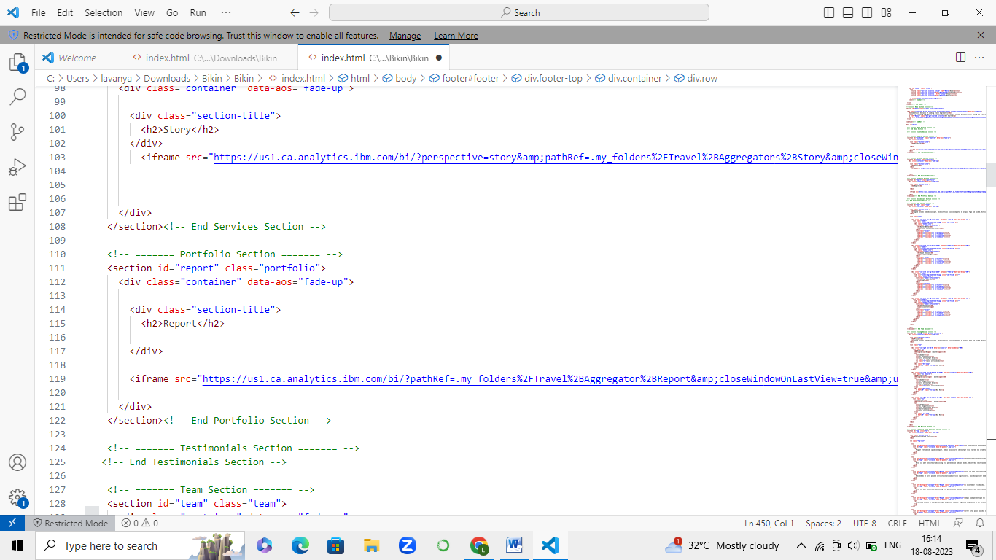

The above code gives the Report of Travel analysis which is being done on IBM Cognus and using the code present in the IBM, we used the dimensions and width to display the image.

**OUTPUT:**

Output is executed in Boot Strap in Bikin template.

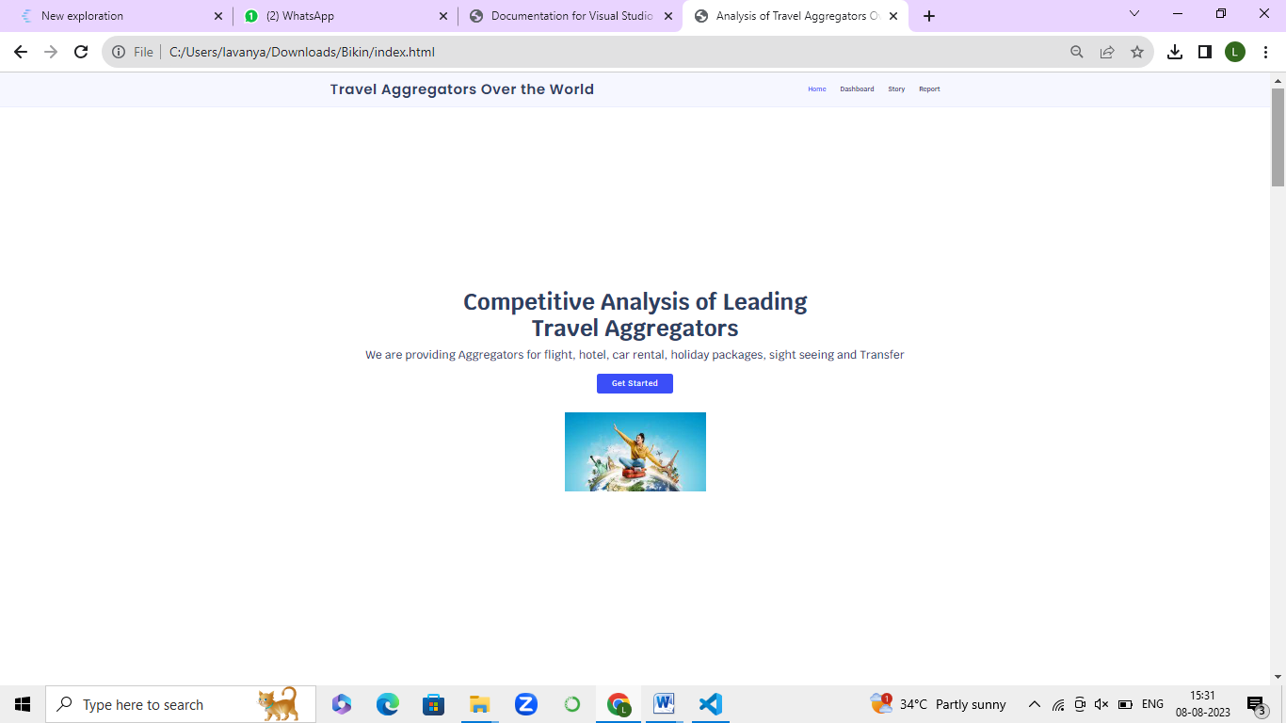



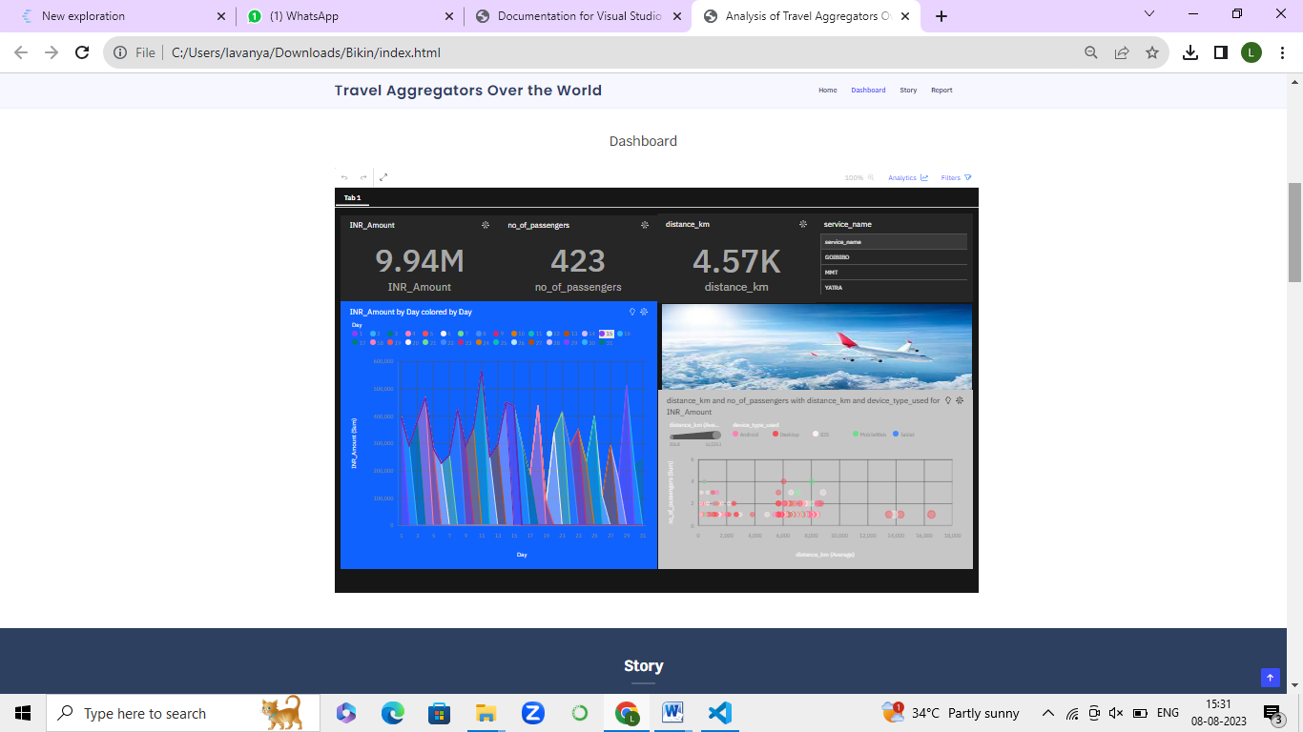

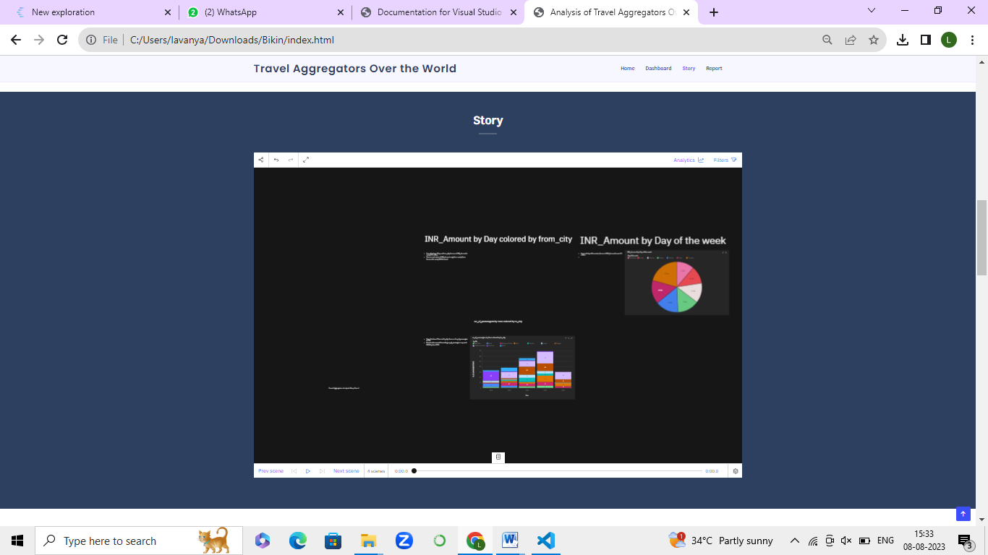



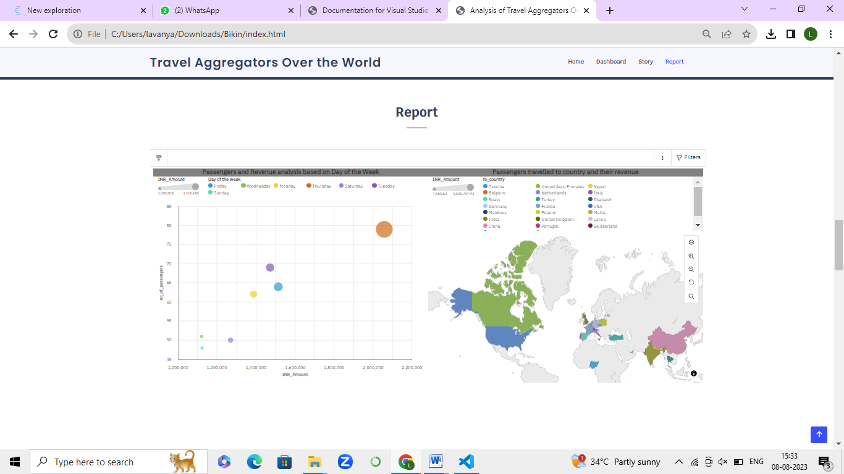

**Data Visualization:**

Data visualization is the process of creating graphical representations of data in order to help people understand and explore the information. The goal of data visualization is to make complex data sets more accessible, intuitive, and easier to interpret. By using visual elements such as charts, graphs, and maps, data visualizations can help people quickly identify patterns, trends, and outliers in the data.

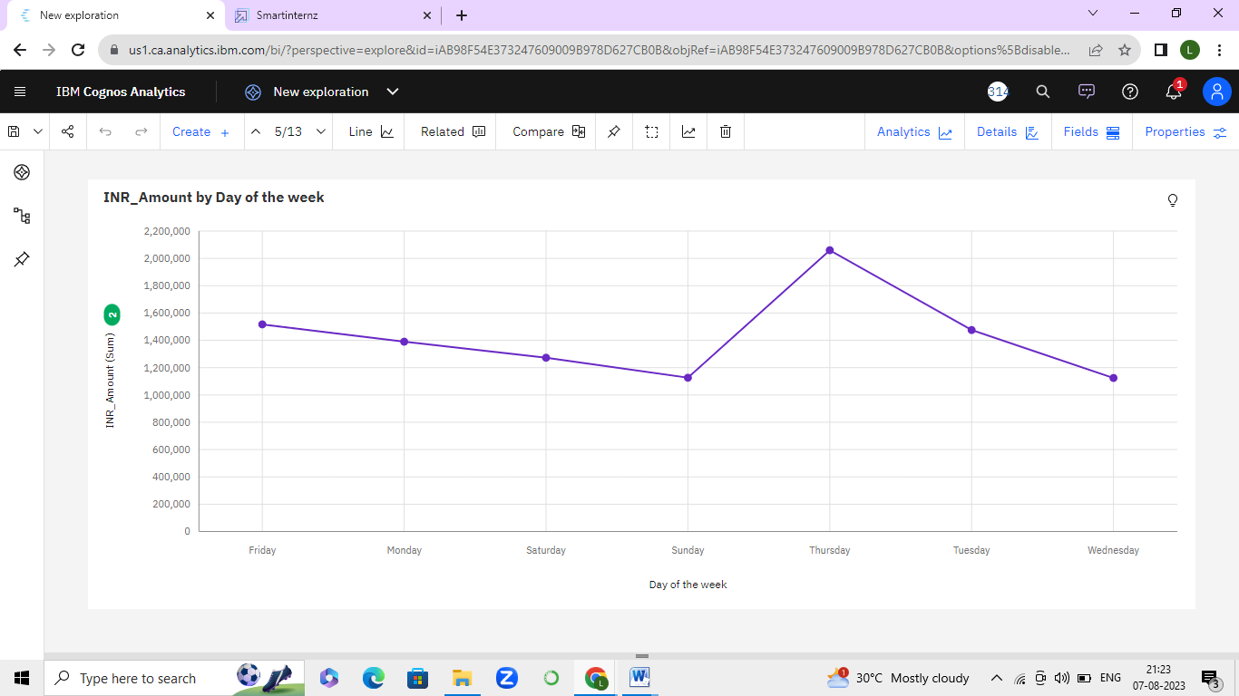



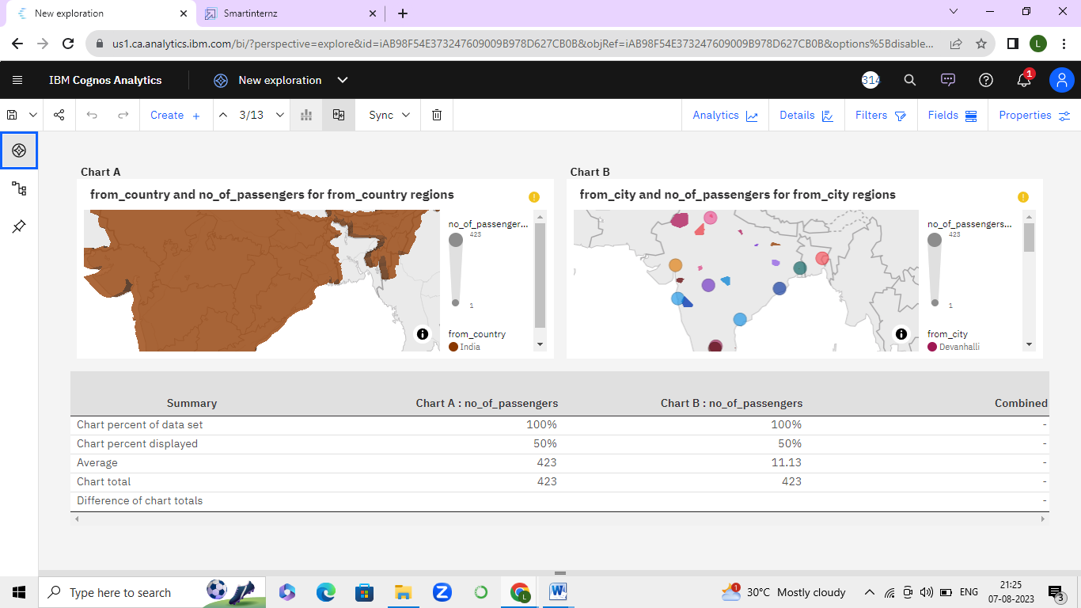

**GITHUB LINK:**

<https://github.com/LavanyaDamalanka/Competitive_Analysis_of_Leading_Travel_Aggregators>

By clicking on the above Github link, we get the following pages which leads us to the code.

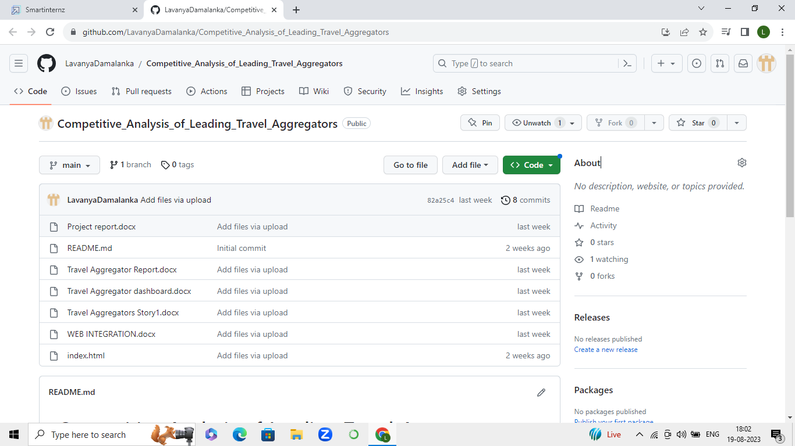

On clicking “index.html”, we’ll be directed to the code.

